Appendix B: Comparison with results from Steinhauser et al model
For each of the two case study data sets in the paper, we compare results from our ‘Model 3’ with results from fitting the model proposed by Steinhauser et al (1). The latter was fitted using the R package ‘diagmeta’ (https://CRAN.R-project.org/package=diagmeta). In keeping with our Models 1-3, we assumed that test results in the diseased and disease-free populations had a log-logistic distribution in each study.
In addition to the most general version of their model, ‘DIDS’ (linear mixed effects model with different random intercepts and different random slopes), Steinhauser et al propose a number of reduced versions (1). We followed Steinhauser et al in selecting the variation of the model with the smallest REML criterion. For both data sets, this was the full ‘DIDS’ model.

Example 1: B type natriuretic peptide for diagnosis of acute heart failure
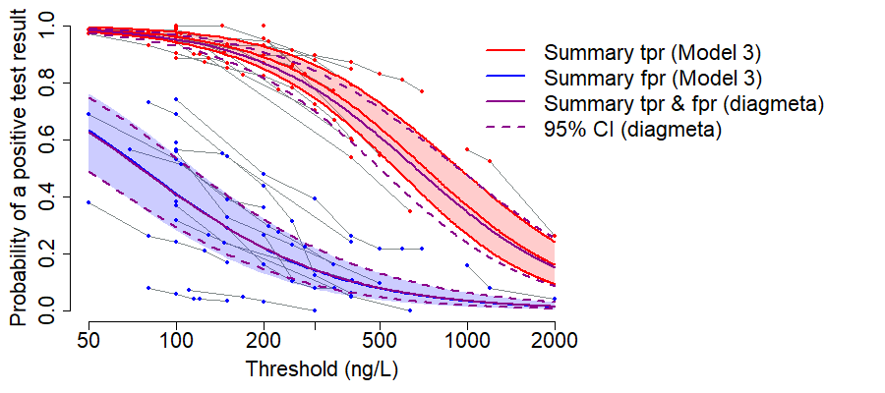
Figure: Summary true positive rate (tpr) and false positive rate (fpr) estimates from Model 3 (with 95% credible intervals) compared with estimates from the Steinhauser et al ‘DIDS’ model, fitted in diagmeta (with 95% confidence intervals).

Across all thresholds: | tpr | fpr
Median difference in summary estimates:  Model 3 - diagmeta | 0.02 | 0.00
Maximum absolute difference in summary estimates | 0.03 | 0.01
Mean width of 95% credible interval (Model 3) | 0.17 | 0.07
Mean width of 95% confidence interval (diagmeta) | 0.19 | 0.07
Table: Difference in summary tpr and fpr estimates (Model 3 vs Steinhauser et al ‘DIDS’ model, fitted in diagmeta) and comparison of width of 95% credible/confidence intervals

Example 2: Spot PCR for diagnosis of pre-eclampsia
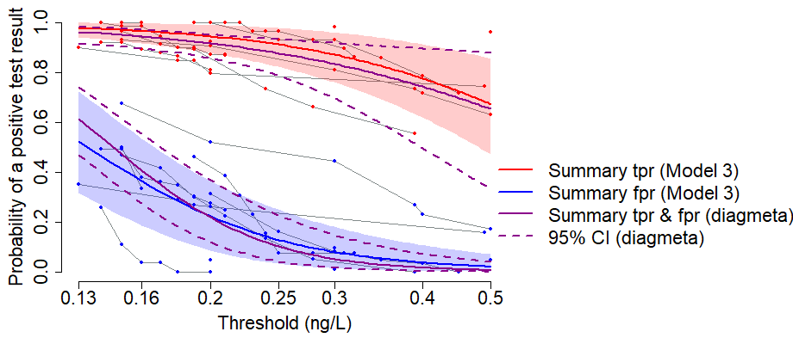
Figure: Summary true positive rate (tpr) and false positive rate (fpr) estimates from Model 3 (with 95% credible intervals) compared with estimates from the Steinhauser et al ‘DIDS’ model, fitted in diagmeta (with 95% confidence intervals).

Across all thresholds: | tpr | fpr
Median difference in summary estimates:  Model 3 - diagmeta | 0.03 | 0.02
Maximum absolute difference in summary estimates | 0.04 | 0.09
Mean width of 95% credible interval (Model 3) | 0.22 | 0.18
Mean width of 95% confidence interval (diagmeta) | 0.27 | 0.14
Table: Difference in summary tpr and fpr estimates (Model 3 vs Steinhauser et al ‘DIDS’ model, fitted in diagmeta) and comparison of width of 95% credible/confidence intervals

References
1. Steinhauser S, Schumacher M, Rucker G. Modelling multiple thresholds in meta-analysis of diagnostic test accuracy studies. BMC Med Res Methodol. 2016;16(1):97.

